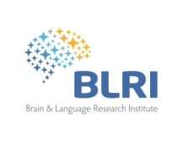

Publications et Communications

Projet ADys

Posters :

Cavalli, E., Colé, P., Badier., J-M., Zielinski, C., Pattamadilok, C., & Ziegler, J.C. (Avril 2015). Spatio-temporal brain dynamics of orthographic, morphological and semantic processing in dyslexic university students : a MEG study. Poster, workshop du Brain and Language Research Institute, Cargèse, France.

Cavalli, E., Colé, P., Badier., J-M., Zielinski, C., Pattamadilok, C., & Ziegler, J.C. (2015, Juillet). Spatio-temporal brain dynamics of orthographic, morphological and semantic processing in dyslexic university students : a MEG study. Poster, 22th annual meeting Society for the Scientific Study of Reading, Hawaii, USA

Article soumis :

Spatio-temporal dynamics of morphological processing in visual word recognition: A priming study using MEG, Journal of Cognitive Neuroscience, Subm 12-Jun-2015
Eddy Cavalli, Pascale Colé, Jean-Michel Badier, Christelle Zielinski, Valérie Chanoine, & Johannes C. Ziegler

Dépôt des données primaires
http://sldr.org/blri-000904

